Test Case: tc006_SPX_Dev5_Crear_Requisicion_Spot_Tipo_Cobro_Proyect_Urgent
Step 1 - Enter username and password and click to button Enter: Credentials Entered
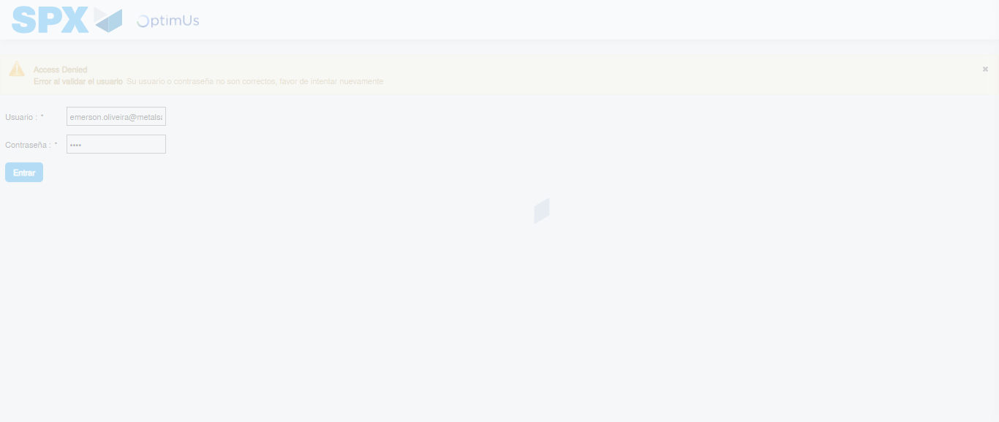Image file-name: QC_Testing-tc006_SPX_Dev5_Crear_Requisicion_Spot_Tipo_Cobro_Proyect_Urgent-1787009289126

Step 2 - Select to UEN and Access to Spot Buy Requisitions : UEN Correctly selected and Correct access
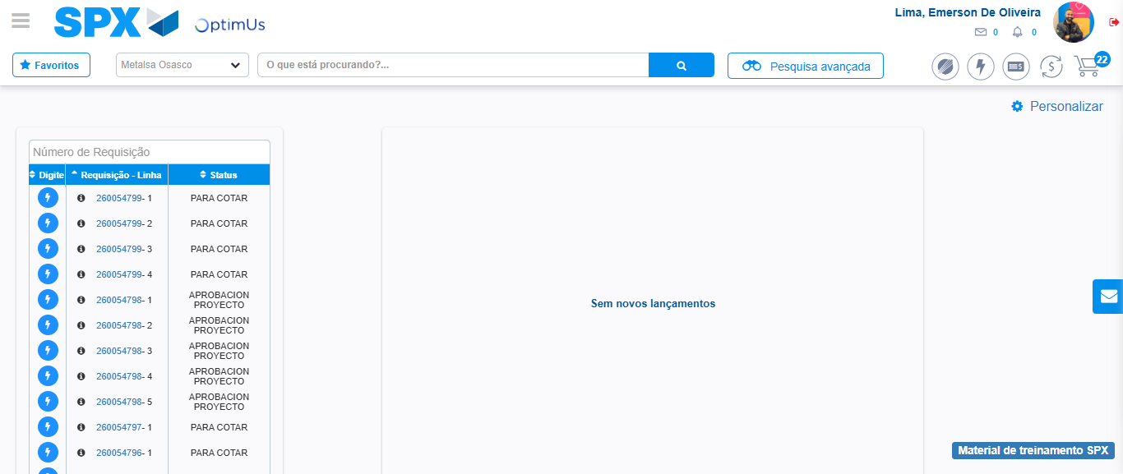Image file-name: QC_Testing-tc006_SPX_Dev5_Crear_Requisicion_Spot_Tipo_Cobro_Proyect_Urgent-1787009316347

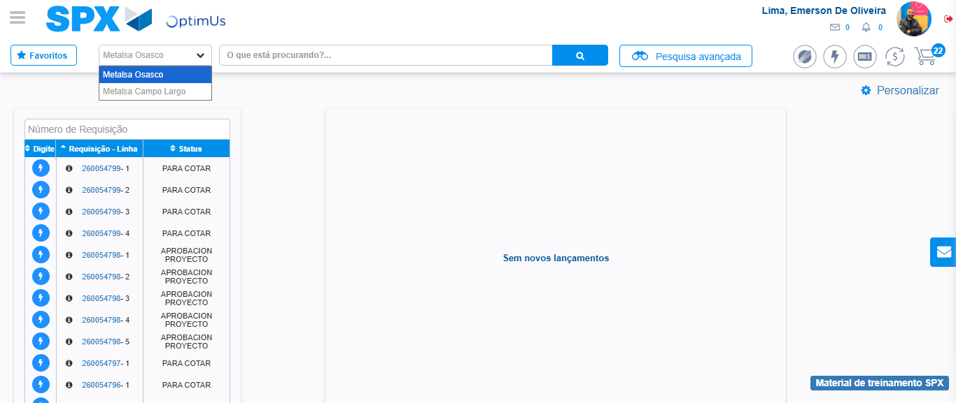Image file-name: QC_Testing-tc006_SPX_Dev5_Crear_Requisicion_Spot_Tipo_Cobro_Proyect_Urgent-1787009318988

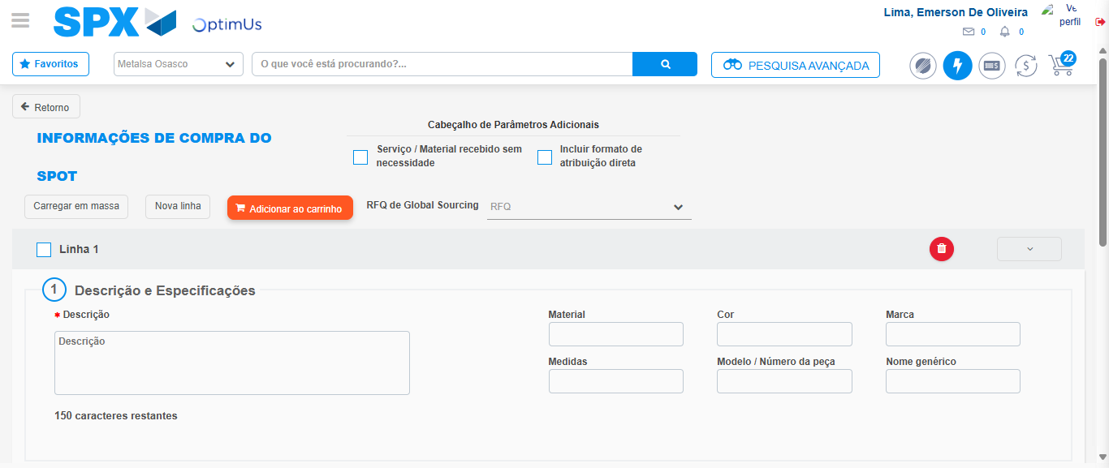Image file-name: QC_Testing-tc006_SPX_Dev5_Crear_Requisicion_Spot_Tipo_Cobro_Proyect_Urgent-1787009340220

Step 3 - Data Capture Spot Buy Requisition: Data captured correctly
Image file-name: QC_Testing-tc006_SPX_Dev5_Crear_Requisicion_Spot_Tipo_Cobro_Proyect_Urgent-1787009340491

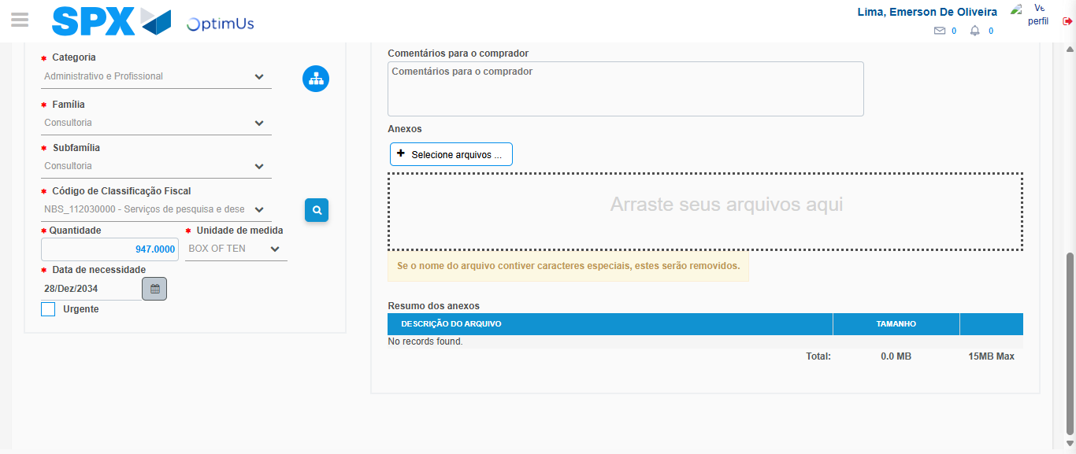Image file-name: QC_Testing-tc006_SPX_Dev5_Crear_Requisicion_Spot_Tipo_Cobro_Proyect_Urgent-1787009358189

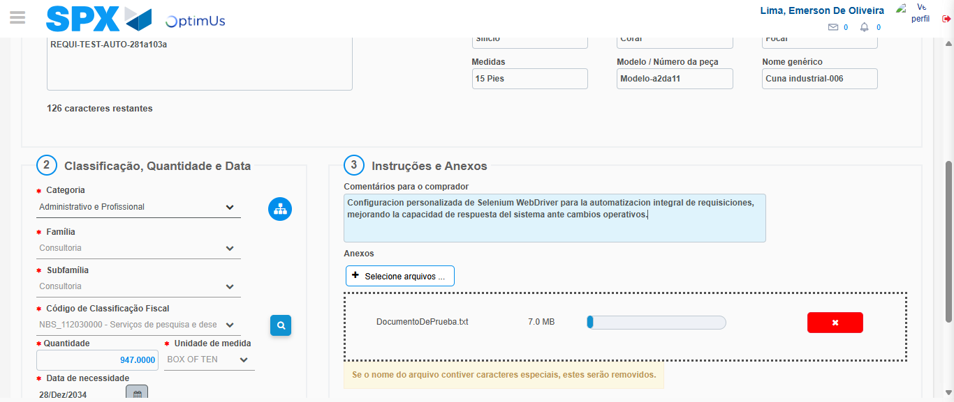Image file-name: QC_Testing-tc006_SPX_Dev5_Crear_Requisicion_Spot_Tipo_Cobro_Proyect_Urgent-1787009359102

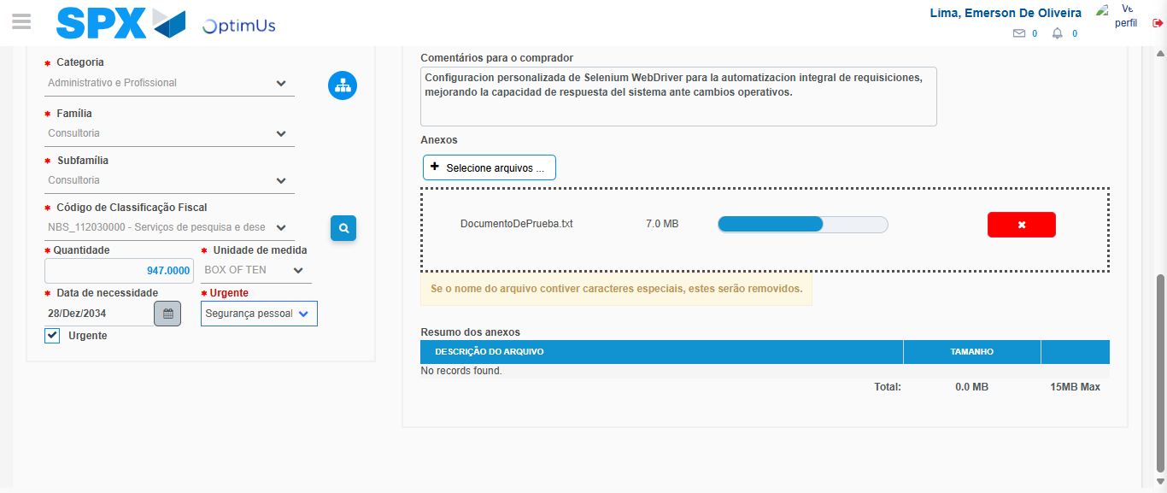Image file-name: QC_Testing-tc006_SPX_Dev5_Crear_Requisicion_Spot_Tipo_Cobro_Proyect_Urgent-1787009362973

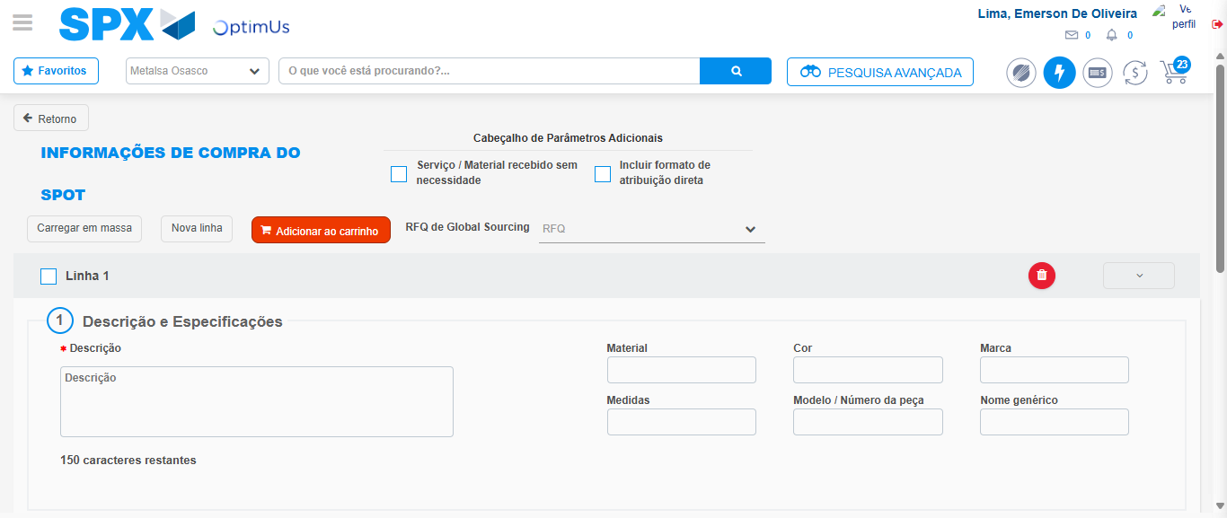Image file-name: QC_Testing-tc006_SPX_Dev5_Crear_Requisicion_Spot_Tipo_Cobro_Proyect_Urgent-1787009372723

Step 7 - Return to Main Page SPX : Return to Main Page SPX
Image file-name: QC_Testing-tc006_SPX_Dev5_Crear_Requisicion_Spot_Tipo_Cobro_Proyect_Urgent-1787009316347

Image file-name: QC_Testing-tc006_SPX_Dev5_Crear_Requisicion_Spot_Tipo_Cobro_Proyect_Urgent-1787009318988

Image file-name: QC_Testing-tc006_SPX_Dev5_Crear_Requisicion_Spot_Tipo_Cobro_Proyect_Urgent-1787009340220

Image file-name: QC_Testing-tc006_SPX_Dev5_Crear_Requisicion_Spot_Tipo_Cobro_Proyect_Urgent-1787009374999

Image file-name: QC_Testing-tc006_SPX_Dev5_Crear_Requisicion_Spot_Tipo_Cobro_Proyect_Urgent-1787009375217

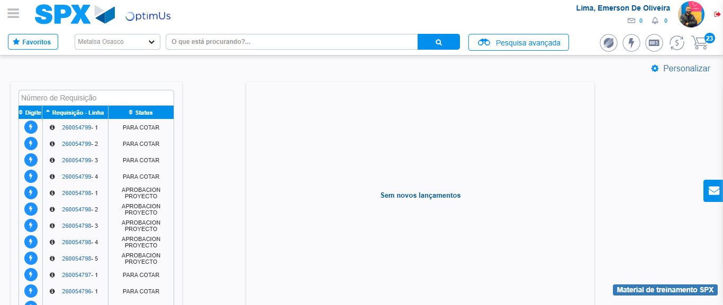Image file-name: QC_Testing-tc006_SPX_Dev5_Crear_Requisicion_Spot_Tipo_Cobro_Proyect_Urgent-1787009396402

Step 8 - Log Out : Log Out SPX
Image file-name: QC_Testing-tc006_SPX_Dev5_Crear_Requisicion_Spot_Tipo_Cobro_Proyect_Urgent-1787009396664

